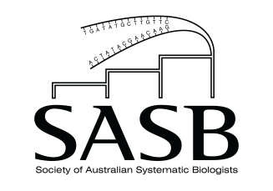

SASB Honorific Award Nominations
Nominations open 1 July and close 1 September of each relevant year

Early Career Research Excellence Award (ECREA)
This annual award will be for researchers who are members of the SASB, and who are <8 years post-Ph.D. in the calendar year of their nomination (NB. Ph.D. students who have not been awarded their degree will not be considered). This honorific award will be judged on performance relative to timeframe/opportunity.

Mid-Career Research Excellence Award (MCREA)
This annual award will be for researchers who are members of the SASB, and who are 8–15 years post-Ph.D in the calendar year of their nomination. This honorific award is to be judged on performance relative to timeframe/opportunity.

Distinguished Career Award (DCA)
This biennial award will be awarded in the year of the SASB conference. It is aimed at recognising a member of the Society who has made an outstanding contribution to systematics, either because of their research, mentoring of ECRs and students, or other relevant professional aspects, or a combination of these activities. The award would normally be for someone in the second half of their career, but there are no limitations on who is eligible, and there is an expectation that the awardee will give an invited presentation at the SASB conference.

Eligibility
All non-student professional members of the Society are eligible to apply, excluding current members of the SASB Council.

Nominations
Nominators must address all the selection criteria listed below. Relevant career interruptions such as illness or caring responsibilities should be outlined clearly.

All applications should be emailed before 11:59 pm AEST on 1 September each year to the current Secretary (SASBiologists@gmail.com; refer to https://www.sasb.org.au/contact). Late applications will not be considered. Resubmission of updated nominations is encouraged. Nominators and nominees must be current financial members of SASB to be eligible.

All nominations must include:

- Nominee’s details: Name/phone/email/position/institution

- A statement that the nominee is aware they have been nominated

- Relevant career interruptions (if applicable)

- A response to the selection criteria
- nominee’s contribution to a relevant field of research (ECREA/MCREA/DCA)
- nominee’s leadership or synergistic activities (e.g. mentoring) (MCREA/DCA only)
- any other relevant information pertinent to the nominee’s standing in the field (ECREA/MCREA/DCA)

- A short CV (ECREA 2 pages max.; MCREA 4 pages max.; DCA 6 pages max) not including publications

- A list of 5/10/20 highlighted publications (ECREA/MCREA/DCA, respectively) with a short explanation of the significance of each

- A complete list of publications (including the highlighted publications)

- Nominator’s details: Name/phone/email/institution/position/relationship to nominee

